Experiment No. 14

Lab 14 – Exception Handling in Python

Exercise:

Q.1

It is possible to catch multiple (different) exceptions that may be raised in a *Try* block using multiple (or a series of) *except* blocks. For example we can write two *Except* blocks; one for catching an *IndexError* and the second is for catching ArthmaticError(by taking two lists consisting of equal no of items ,and perform division with each pair of list elements). Remember that the *IndexError* is raised when an element of an array whose index is out of the range of the array is accessed. An out of range index can be either less than zero or greater than or equal to the size of the array. The code below demonstrates the use of multiple *Except* blocks

**CODE:**

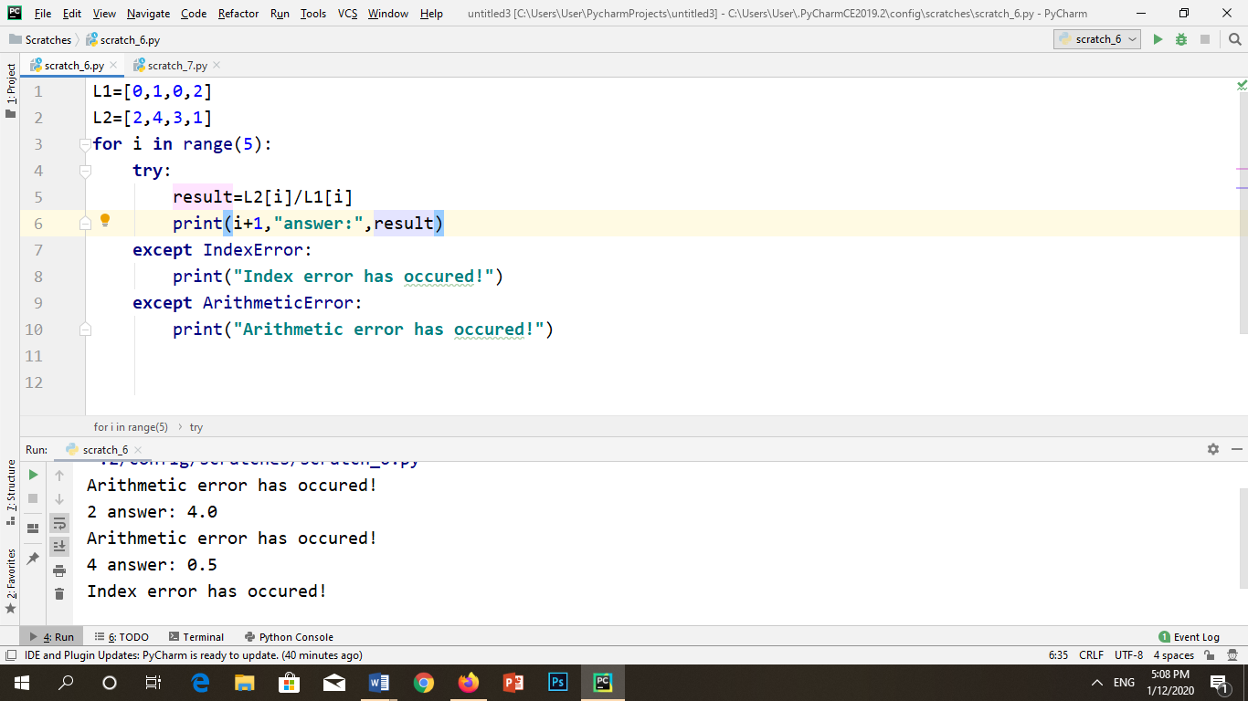

**OUTPUT:**



Q.2.

Design a python program to demonstrate EOF Error by using Try-Except Block

**CODE:**

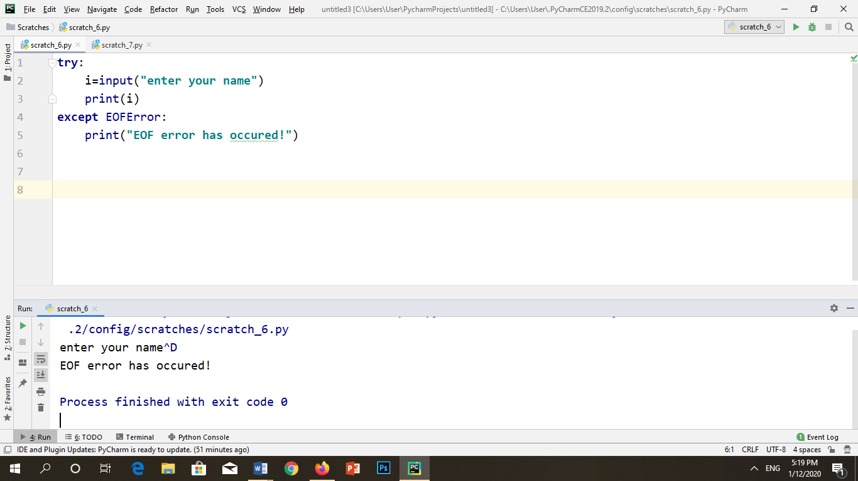

**OUTPUT:**

. 

Q.3

Design a python program to demonstrate IndentationError by using Try-Except Block.

**CODE:**

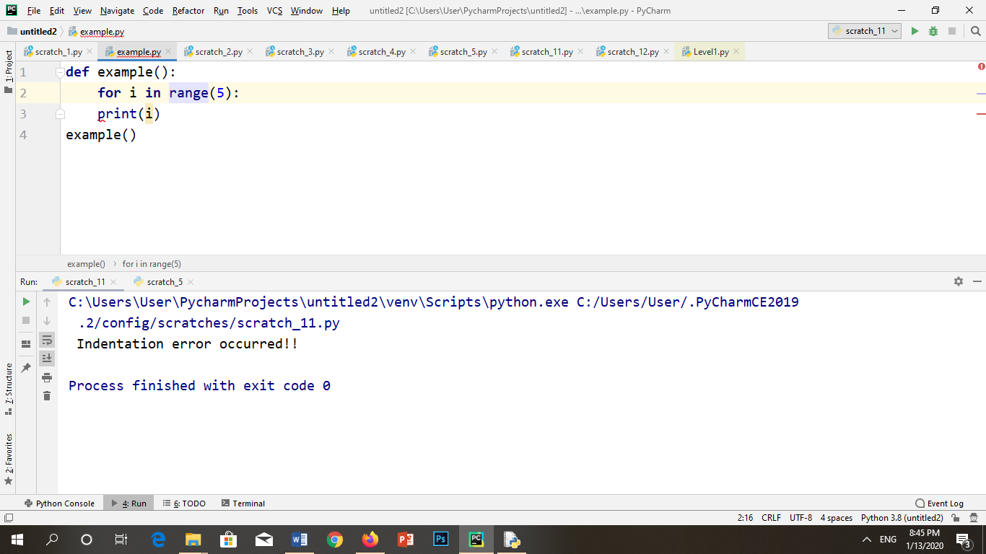

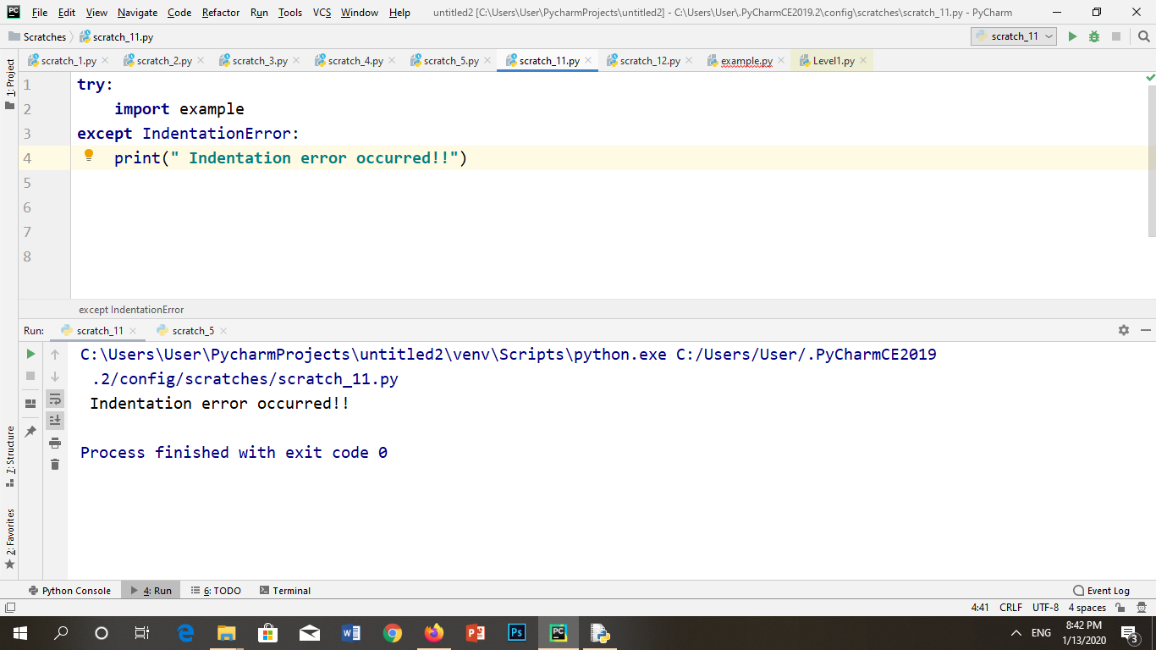

**OUTPUT:**



Q.4

Design a python program to demonstrate IOError by using Try-Except Block.

**CODE:**

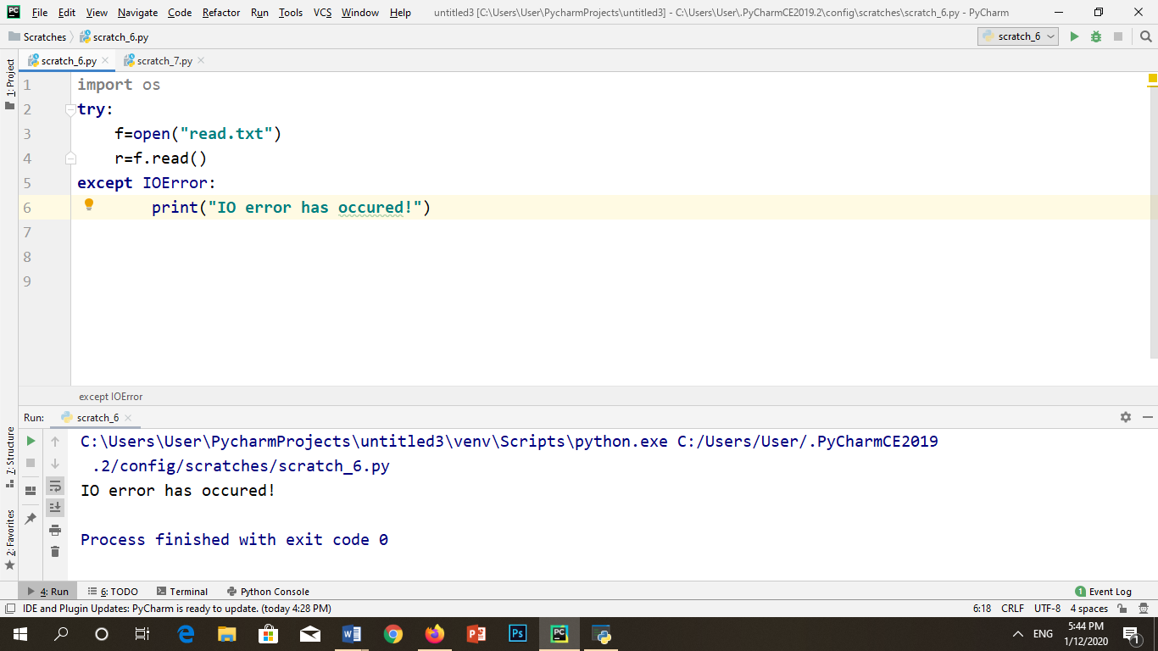

**OUTPUT:**

